1. Mechanical Design

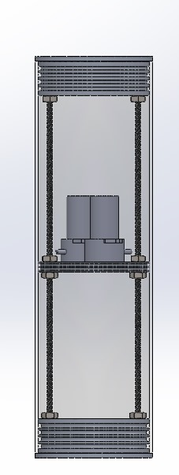

**Figure 1: Illustrates the float mechanism, including the peristaltic pumps, 6 mm lead screws, ertalon disk, and fastening nuts.**

The float system consists of a transparent acrylic cylinder with a length of 40 cm, an outer diameter of 12 cm, and a density of 1.19 g/cm³. Its specifications provide sufficient water displacement, maximizing buoyancy according to Archimedes' principle:

$F_{B}={ ρ}_{water} × g × V_{disp}$

The acrylic cylinder, with a **wall thickness of 3 mm** can withstand sufficient pressure, making it suitable for its application. Its transparency allows for visual inspection and error detection, unlike other opaque materials such as PVC or Ertalon. PVC also has a higher density, deteriorating buoyancy.

An Ertalon disk, a material with a density close to water, is positioned to divide the cylinder into two sections. The upper section houses the electrical components, while the lower section serves as a water chamber for density control. The disk features two grooves to mount O-rings, ensuring a secure isolation between the two sections. Additionally, chemical sealing agents such as epoxy are used to reinforce the isolation.

The suction system uses two peristaltic pumps for suction and ejection, operating at a flow rate of 60 ml/min, allowing the 700 ml container to be filled or emptied in approximately six minutes per operation. These pumps function by compressing a flexible tube with rotating rollers, generating a wave-like motion that pushes fluid through the tube, allowing precise flow control. To prevent any leakage, the inlet and outlet hoses pass through PG-9 glands using 8mm pneumatic hose.

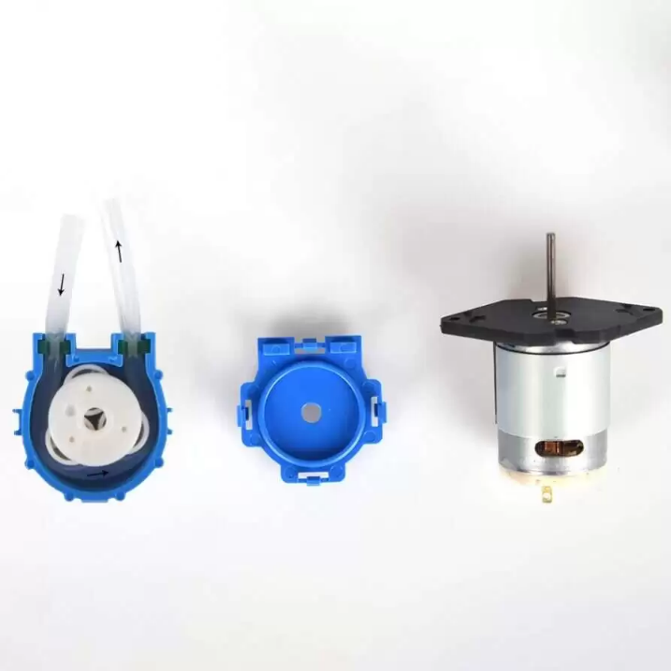

**Figure 2 illustrates the peristaltic pump inner parts and mechanism.**

Two 6 mm lead screws are used to fix all system parts in place with the aid of nuts. To close the system, two 3-D printed caps are used; each of them has multiple grooves to mount O-rings enclosed with another two Ertalon disks that serve as mounts for the lead screws and nuts.

1. **Electrical Design**
   1. **Main System**

The float's electrical system is designed on a single PCB to simplify maintenance and ensure reliable operation. This PCB integrates the STM32 microcontroller, a Real-Time Clock (RTC) module, an NRF24L01 radio module, a custom depth sensor (MS5837), an L298N motor drive, and multiple power converters to maintain stable performance.

The STM32 serves as the main controller, interfacing with the RTC, NRF24L01, MS5837 depth sensor, and L298N motor driver. It processes data from these components and transmits the collected information to the control station via a 2.4 GHz radio link.

During vertical profiling, STM32 records sensor data at specific time increments while controlling the buoyancy engine to operate at equal intervals. The recorded data is stored along with the corresponding timestamps, ensuring accurate tracking of measurements throughout the profiling process. To accommodate the large volume of recorded data, an external EEPROM chip is connected to the STM32. The NRF24L01 radio module is responsible for transmitting all stored data to the control station, ensuring efficient data communication and retrieval.

* 1. **Battery Selection and Management**

To ensure a stable and reliable power supply, NiMH batteries were selected. The system consists of 20 NiMH cells. Ten cells are connected in series to provide a 12-volt output, and another set of 10 cells is connected in parallel with the first set. This configuration effectively increases both the current and capacity while maintaining the required voltage.

The first 10 cells are divided into two packs, each containing 5 cells connected in a series. These two packs are then connected in series with each other to form the full 10-cell series configuration. This arrangement provides the necessary 12-volt output while ensuring efficient power delivery and stable operation.

The entire system is charged using an external balance charger. This charger is responsible for balancing the voltage across the cells, ensuring uniform charging, preventing overcharging, and prolonging battery life.

* 1. **Fuse Calculations**

|  |  |  |  |  |  |
| --- | --- | --- | --- | --- | --- |
| **Component** | **Quantity** | **Voltage** | **Current** | **Power Per Unit** | **Total Power** |
| NRF24L01 | 1 | 3.3 | 0.115 | 0.3795 | 0.3795 |
| RTC | 1 | 5 | 0.1 | 0.5 | 0.5 |
| EEPROM | 1 | 5 | 0.01 | 0.05 | 0.05 |
| STM32 F411 | 1 | 5 | 0.25 | 1.25 | 1.25 |
| Pumps/Motors | 2 | 12 | 1 | 12 | 24 |
| **Total** |  | | | | **26.1795** |

TOTAL POWER = 26.18W  
Safety Factor = 1.5  
Result = 3.2724375

REQUIRED FUSE: 5A